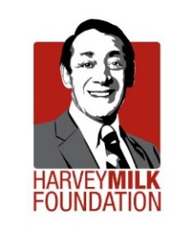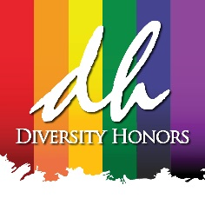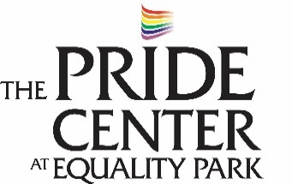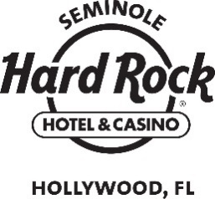

MEDIA CONTACT:
Michael Goodman
GPR│Goodman Public Relations
(954) 806-2869
michael@goodmanpr.com

THIRD ANNUAL DIVERSITY HONORS IS SET TO CELEBRATE LEADERS FOR EQUALITY IN HONOR OF HARVEY MILK ON SATURDAY, MAY 6 AT HARD
ROCK LIVE PRESENTED BY THE SEMINOLE HARD ROCK HOTEL & CASINO

FORT LAUDERDALE (January 31, 2017) – The third annual Diversity Honors, co-presented by the Harvey Milk Foundation and The Pride Center at Equality Park, is set to take center stage at Hard Rock Live presented by the Seminole Hard Rock Hotel and Casino at 7 p.m. on Saturday, May 6 as a kick-off to Harvey Milk Day events around the world. This prominent event will again showcase those who are transforming lives by living authentically and advancing inclusiveness.

This collaborative effort between The Harvey Milk Foundation and The Pride Center at Equality Park along with generous support from the Seminole Hard Rock Hotel and Casino has put South Florida on the international stage of LGBTQ rights and activism in honor of Harvey Milk, one of the first openly gay elected officials in the United States who was assassinated shortly after winning a seat on the San Francisco Board of Supervisors. This year marks the 40th anniversary of the election of Harvey Milk to public office. The honorees for the 2017 Diversity Honors will be announced at a later date.
Diversity Honors has raised more than $120,000 in support of The Harvey Milk Foundation and The Pride Center at Equality Park while paying tribute to an impressive roster of honorees over the past two years. Honorees include: civil rights activists Judy and Dennis Shepard, recipients of the Harvey Milk Medal; Bollywood star Celina Jaitly who received the Harvey Milk Foundation’s Lilla Watson Global Champion Medal; eight-year-old transgender YouTube viral inspiration Ryland Whittington and transgender teen activist Jazz Jennings, both recipients of the annual Harvey Milk Foundation Milan Rozsa Award plus Joey Arias, Peter Clark, Enbar Cohen, Deborah Cox, Mark Denker, Rae Franks, Esq., Rand Hoch, Norm Kent, Elaine Lancaster (James Davis), Robert Runcie, Lillian Tamayo, Fort Lauderdale Commissioner Dean Trantalis, Judge William Thomas and Judge David Young.

Businesses and individuals that are interested in supporting Diversity Honors are encouraged to contact Roger Roa at The Pride Center at 954-463-9005. For more information about Diversity Honors, visit www.DiversityHonors.com.

About The Harvey Milk Foundation
The Harvey Milk Foundation is a global non-profit NGO that promotes Harvey Milk’s inspiring legacy through human rights education and global outreach. In 1977, Harvey Milk (1930-1978) became the first openly LGBT elected official to a major office in the United States. He was assassinated in San Francisco’s City Hall 11 months later. The all-volunteer run foundation was founded by Harvey's nephew, Stuart Milk, and Anne Kronenberg, Harvey's campaign manager and political aide. Today, the Harvey Milk Foundation provides on-the-ground support and award-winning programing to struggling and emerging LGBT communities on 5 continents with over four dozen dedicated volunteer leaders and long term partnerships in 31 nations. For more information, please visit www.milkfoundation.org.

About The Pride Center at Equality Park
For more than 20 years, The Pride Center has provided a welcoming, safe space – an inclusive home – that celebrates, nurtures and empowers the LGBT communities and our friends and neighbors in South Florida. The Pride Center’s programs and services meet the distinct socio-economic, health, spiritual, and safety needs of the LGBT community. It hosts more than 60 regular meeting groups each month and more than 35,000 adults and youth attend activities at the Center, each year. Outreach activities over the past year directly impacted 50,000 residents and visitors to South Florida. The Pride Center is a major site for HIV testing and prevention, education and counseling and offers holistic and comprehensive support programs for persons living with HIV/AIDS, including the nationally acclaimed PALS Project. For more information, visit www.pridecenterflorida.org.

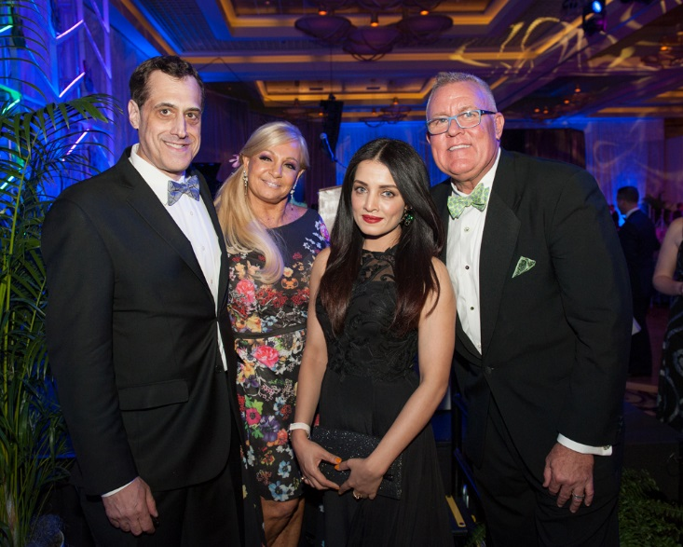
Stuart Milk, Susan Renneisen (VP Community Affairs & Special Events, Seminole Hard Rock Hotel and Casino), Celina Jaitly (Bollywood actress and global human rights activist) and Robert Boo at last year’s successful event.

PHOTO CREDIT: Michael Murphy Photography

# # #

